# PRACTICAL NO. 4

**IR ANALYSIS OF A MODERN DRUG**

## DATE: 30/09/22

# AIM:

To obtain infrared spectra of Diclofenac Sodium and Glucose using Fourier Transform Infrared Spectroscopy (FTIR).

# INTRODUCTION:

FTIR is commonly used for qualitative analysis. It can characterize nature of strong interaction; it can also determine fraction of interacting group in certain H bonded system. It is possible to find the IR spectrum of sample in various states like solid, liquid or gas. Material that is opaque to IR radiation must be diluted or dissolved in transparent matrix in order to obtain spectra. There are special accessories like liquid cell for that matter. The technique is based on a simple fact that a chemical substance shows a selective absorption in infrared region. After absorption of IR radiation, the molecule of chemical substance vibrates at different rate of absorption, giving rise to close peak absorption band called as an ‘IR absorption spectrum’. This spectrum may extend over wide wavelength range. Three various bands will absorb in IR spectrum which will correspond to characteristic functional group and band present in chemical substance. The IR region is divided in 3 regions:

1. Near IR: Wavelength range is approximately 12800 - 4000 cm-1 this region is called high energy near IR. Sample containing moisture can be detected in this group.
2. Mid IR: Wavelength range is approximately 4000 - 200 cm-1, this region may be used to study the fundamental vibrations and associated rotational vibrational structures.
3. Far IR: Wavelength range is approximately 200 – 10 cm-1, this wave is placed before the microwave region. It has low energy and used for rotational spectroscopy before 400 cm-1.

|  |  |  |
| --- | --- | --- |
| TYPE | WAVELENGTH | NUMBER (cm-1) |
| Near IR | 0.78 -2.5 | 12800-4000 |
| Mid IR | 2.5-5.0 | 4000 - 200 |
| Far IR | 5.0-1000 | 200 – 10 |

As infrared spectrum represents, a fingerprint of sample with absorption peak. Since each material consist of a unique combination of atom. No two compounds produce identical spectra. Thus, the IR spectrum of a chemical substance is a fingerprint for its identification. Hence it is a good analytical tool and can be used for different materials. An IR spectroscopy is based on change in the vibrational energy of a molecule when it is exposed to IR region molecule absorbs the specific frequencies that are characteristic to their structure. These frequencies of absorbed radiation match with frequency of the band on group that vibrate in the molecule in order to molecule to be IR active change in vibrational energy should take place, which is associated with change in permanent dipole moment of atom in the molecule. A molecule can vibrate in different ways and

each way is called a vibrational mode. For the molecule with ‘n’ number of atoms in it a linear molecule is shown to have 3n-5 degree of vibrational mode where non-linear molecule is [shown to have 3 -6 degree of vibrational mode. A simple diatomic molecule has only one band and only one vibrational mode. If molecule is symmetric like N2 the band is not observed in the IR spectrum, but only in Raman spectrum only asymmetric molecule like CO2 absorbs in the IR spectrum. The atom on the CH2X2 group , commonly found inorganic compound where ‘x’ can represent any other atom, can vibrate in different way. Six of this vibration can occur in the CH2 group itself are as follow :

* 1. Symmetrical stretching
  2. Asymmetrical stretching
  3. Scissoring
  4. Rocking
  5. Wagging
  6. Twisting

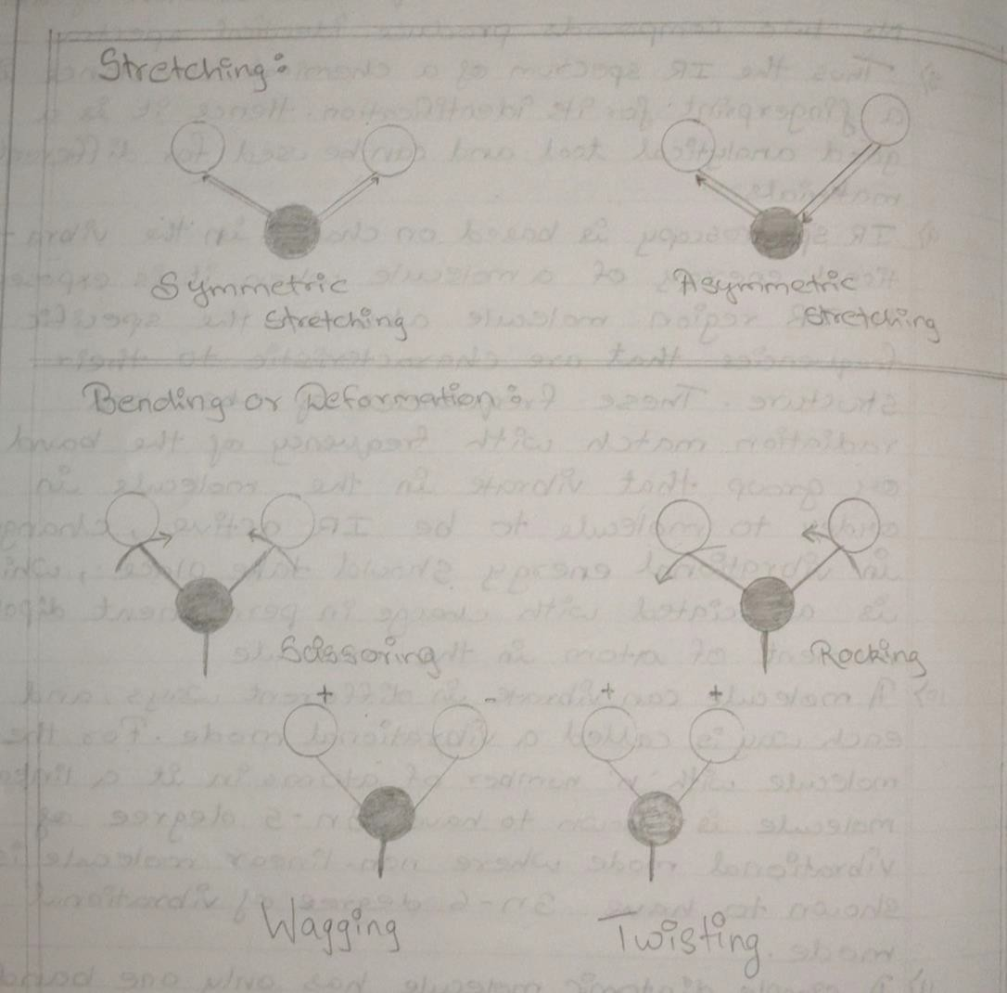

# PRINCIPLE :

IR spectroscopy is used to study the interaction between matter and electromagnetic field in IR region. In this spectral region the electromagnetic wave mainly couples with molecular vibration. In other word, molecule can be excited to higher Vibrational state by absorbing IR radiation The probability of a particular IR frequency being absorb depend on the actual interaction between frequency and the molecule. In general, a frequency will strongly absorb in photon energy coincide with vibrational energy level of molecule.

### Instrumentation of Fourier Transform Infrared Spectroscopy

Instrument consists of 5 parts:

1. Source
2. Interferometer
3. Sample holder
4. Detector
5. Recorder

## SOURCE:

IR source consists of an inert solid that is heated electronically to a temperature between 1500- 2000K. IR energy is emitted from a glowing black body source. These are different types of sources in FTIR spectroscopy.

**Nerst Glober:** It is fabricated from rare Earth oxide (eg ZrO2, I2O2) temperature range is 1200- 2200K.

**Globar:** It is in the form of silicon carbide rod, which is 50mm in length and 5mm in diameter and heated at 1300 – 1500K.

**Incadescent Wire Source:** Nichrome or Rhodium wire is electrically heated at 1200-1000K.

**Carbon Dioxide Laser:** CO2 laser gas mixture consist of 70 % Helium , 15%. CO2 and 15% N2 this source is much more intense than black body sources.

**Mercury Arc:** It is used in far IR region (λ > 50 µm).

**Tungsten Filament:** It is used the near IR region (2.5 – 0.7 µm).

## INTERFEROMETER:

It works on the principle of Beer Lambert's Law. It is also referred to as a Michelson's interferometer. The light from the source, it is split by central mirror or beam splitter into two beams of equal intensities. The reflected beam goes to the fixed mirror and other to the moving mirror. The reflected light by beam splitter recombines and passes through sample eventually to the detector. Thus, the interferogram is produced.

## SAMPLE HOLDER:

It holds the sample; the beam enters in the sample compartment where it is transmitted through or reflected off the surface of the sample depending on the type of analysis being accomplished. This is where specific frequency of energy which are uniquely specific to a sample are absorbed.

## DETECTOR:

The beam finally passes through the detector for final measurement. The detectors used are specifically designed to measure the special interferogram signal. Many different types of detectors are used which are as follow :

1. Thermal detector
2. Photo conducting detector
3. Pyroelectric detector

## COMPUTER RECORDER:

The measure signal is digitalized and send to the computer when the fourier transformation take place. The final infrared spectrum is then presented to the user for interpretation and further manipulation.

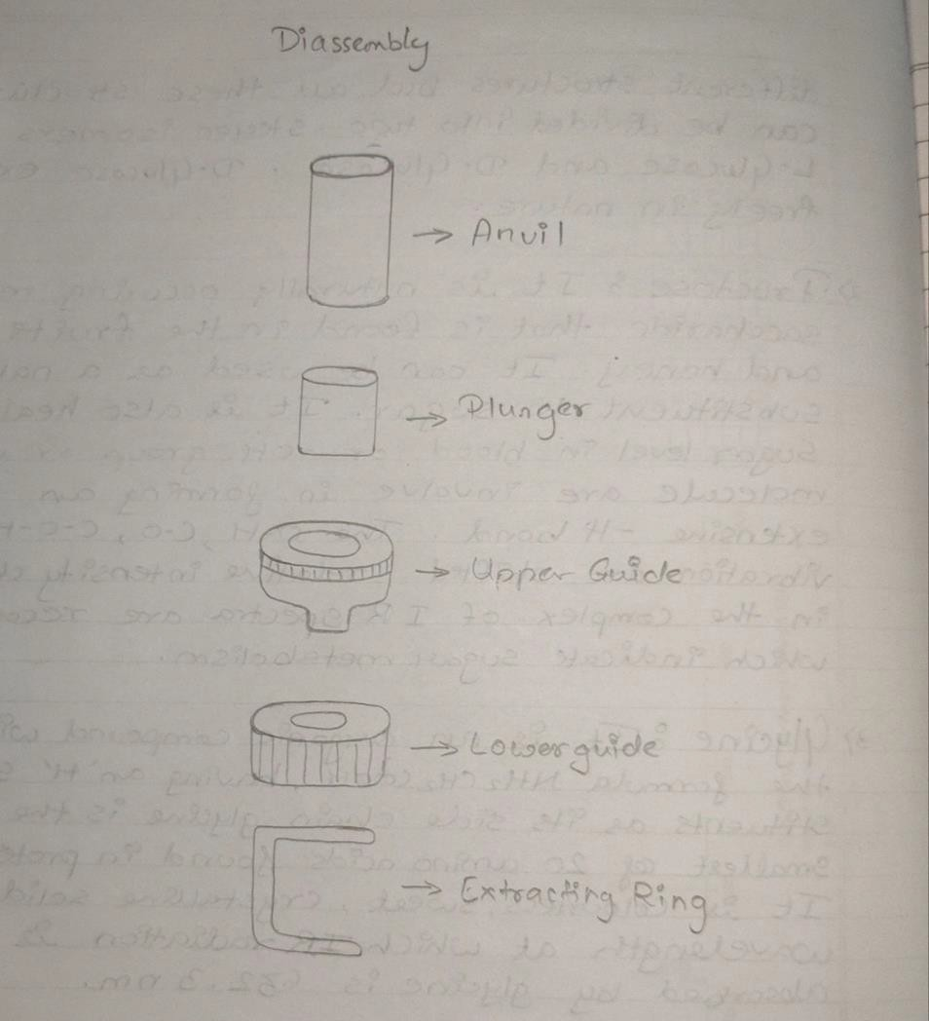

### Michelson's Interferometer

FTIR spectroscopy consist of an instrument which is known as Michelson's interferometer. This instrument observes the rule of Beer Lambert law. The basis of Michelson's interferometer consists of:

* A broad band light source which emits light in mid IR region.
* A beam splitter made up of CsI and KBr.
* A specific detector.
* Two front surface coated mirror - one moving and one fixed.

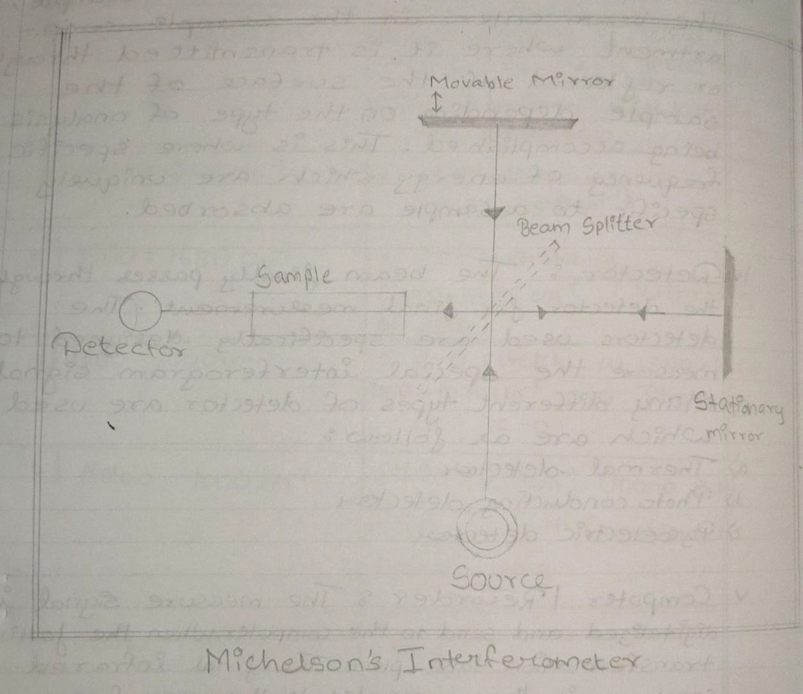

### Working Principle of Michelson's Interferometer:

Light from the light source is directed to the splitter. Half of the light is reflected and half of light is transmitted through splitter. Reflected light goes to the fixed mirror, where it is reflected back to beam splitter. The transmitted light is sent to moving mirror and is also reflected back to beam splitter. At the beam splitter, each of two beams are split into two. One goes back to light source and other goes towards the detector. Hence the detector detects, two beams one from moving mirror and other from fixed mirror. The beam reaching the detector come from the same source and have an optical path

difference determined by the position of two mirror i.e., they have a fixed phase difference in two beam interferences. If a mirror is scanned over a range , a sinusoidal signal will be detected from frequency, with the maximum and minimum corresponding to constructive and destructive interference respectively. The signal is called as "INTERFEROGRAM.

## ADVANTAGES OF FTIR :

* Universal Technique
* Sensitivity 10-6 grams
* Fast and easy
* Relatively an expensive
* Majority of molecule absorb mid IR radiation making it highly useful tool

## ADVANTAGES OF FTIR OVER DISPERSIVE IR :

* **Felgett advantages**: Because all of the frequencies are measured simultaneously, most measure of FIIR are made in few seconds.
* **Jacquinot throughput advantages**: Sensitivity is dramatically improved with FTIR for many reasons, the detector employed are much more sensitive. The optical throughput is much higher which result in the lower noise level and scan in order to reduce the random measurement noise to any desire level.
* In the instrument, there are fewer possibilities of mechanical breakdown since the moving mirror is the part of instrument.
* This instrument is self-calibrated and never needs to be calibrated by user.

## APPLICATIONS OF FTIR :

* It is useful in identifying substances and confirm their identity.
* This spectroscopy has been highly successful for the application to organic chemistry.
* It is used in both research and industries as simple and reliable technique for quality control and dynamic measurement.
* It is successfully utilized in the field of semiconductor. Micro-electronic like silicon, zinc selenide, galium nitride , silicon nitride amorphous silicon etc.

### Use of Potassium Bromide (KBr) in FTIR :

The pellet preparation method in PIIR explain the property that alkali halide becomes transparent when subjected to high pressure and form a sheet that is transparent on the IR region. KBr is used because it does not absorb at any infrared radiation in the region of 4000-650 cm-1. KBr is inert in nature and it does not react with sample to be analyzed. It helps in better resolution of beam of analyte as it does not show any absorbance in any region. It is also highly stable, so the background scanned once can be used for a longer duration of analysis. Cesium Iodide (CsI) can also be used to measure

in the infrared spectrum in the 4000 - 250cm-1 region but generally it is prevented as it is costly than KBr.

### Samples Analysed using FTIR :

* Glucose (C6H12O6): It is a carbohydrate and is the most important sugar in metabolism. It is a monosaccharide. It can exist in several different structures but all these structures can be divided into two stereoisomers, L-Glucose and D-Glucose. D-Glucose exists freely in nature.
* Diclofenac Sodium (DFS): DFS is a non-steroidal , anti-inflammatory drug taken to reduce the inflammation and analgesic to reduce pain in certain condition. It is available as generic drug in number of formulations like tablet, injection, etc. It is yellowish hydroscopic crystalline powder, soluble in alcohol. It is useful in treatment of arthritis, rheumatoid, osteoarthritis and in treatment of chronic.

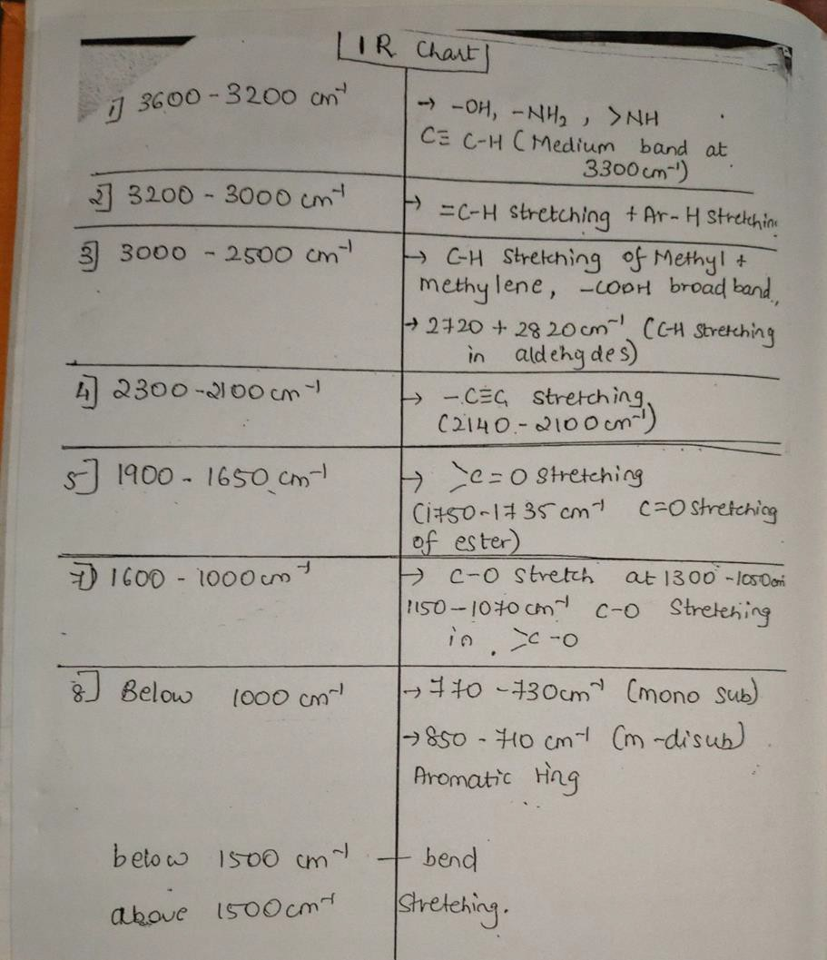

# REQUIREMENTS:

* Glasswares:
  1. Beaker
  2. Petriplate
* Chemicals:

1. Chloroform
2. Potassium Bromide (KBr)

* Sample:

1. Glucose
2. Diclofenac Sodium (DFS)

* Instruments:

1. Shimadzu FTIR; Model no. IR Affinity-1
2. Source: High energy ceramic filament
3. Interferometer: Michelson’s interferometer
4. Detector: Pyroelectric detector

* Miscellaneous:

1. Pellet preparation assembly:
   1. Die assembly (Bottom guide, top guide, plunger, anvil)
   2. Extraction ring
   3. Hydraulic press pump
2. Sample holder
3. Spatula
4. Mortar and pestle
5. Oven dry box
6. Tissue paper
7. Data recorder

# PROCEDURE:

1. Clean the mortar and pestle with chloroform.
2. Add KBr and Diclofenac sodium (DFS)/Glucose into pestle and mortar with the ratio 98:2 & crush mixture into fine powder.
3. Clean the anvil and plunger with chloroform to remove impurities.
4. Assemble top and bottom guide and insert the anvil with polish surface upwards in the apparatus.
5. Fill the sample carefully inside the cavity of die assembly apparatus
6. Insert the plunger with polish surface facing downwards.
7. Transfer the die assembly to the hydraulic pressure pump and apply pressure on hydraulic pump.
8. Apply constant pressure of 10 tons for 10 minutes.
9. After 10 minutes remove pellet assembly from hydraulic pump.
10. Remove the bottom guides existing using extraction ring by as applying pressure from reverse side to remove the pellet.
11. Transfer the pellet carefully to the sample holder in the FTIR machine and record the spectrum.

# OBSERVATIONS:

* + GLUCOSE SPECTRUM

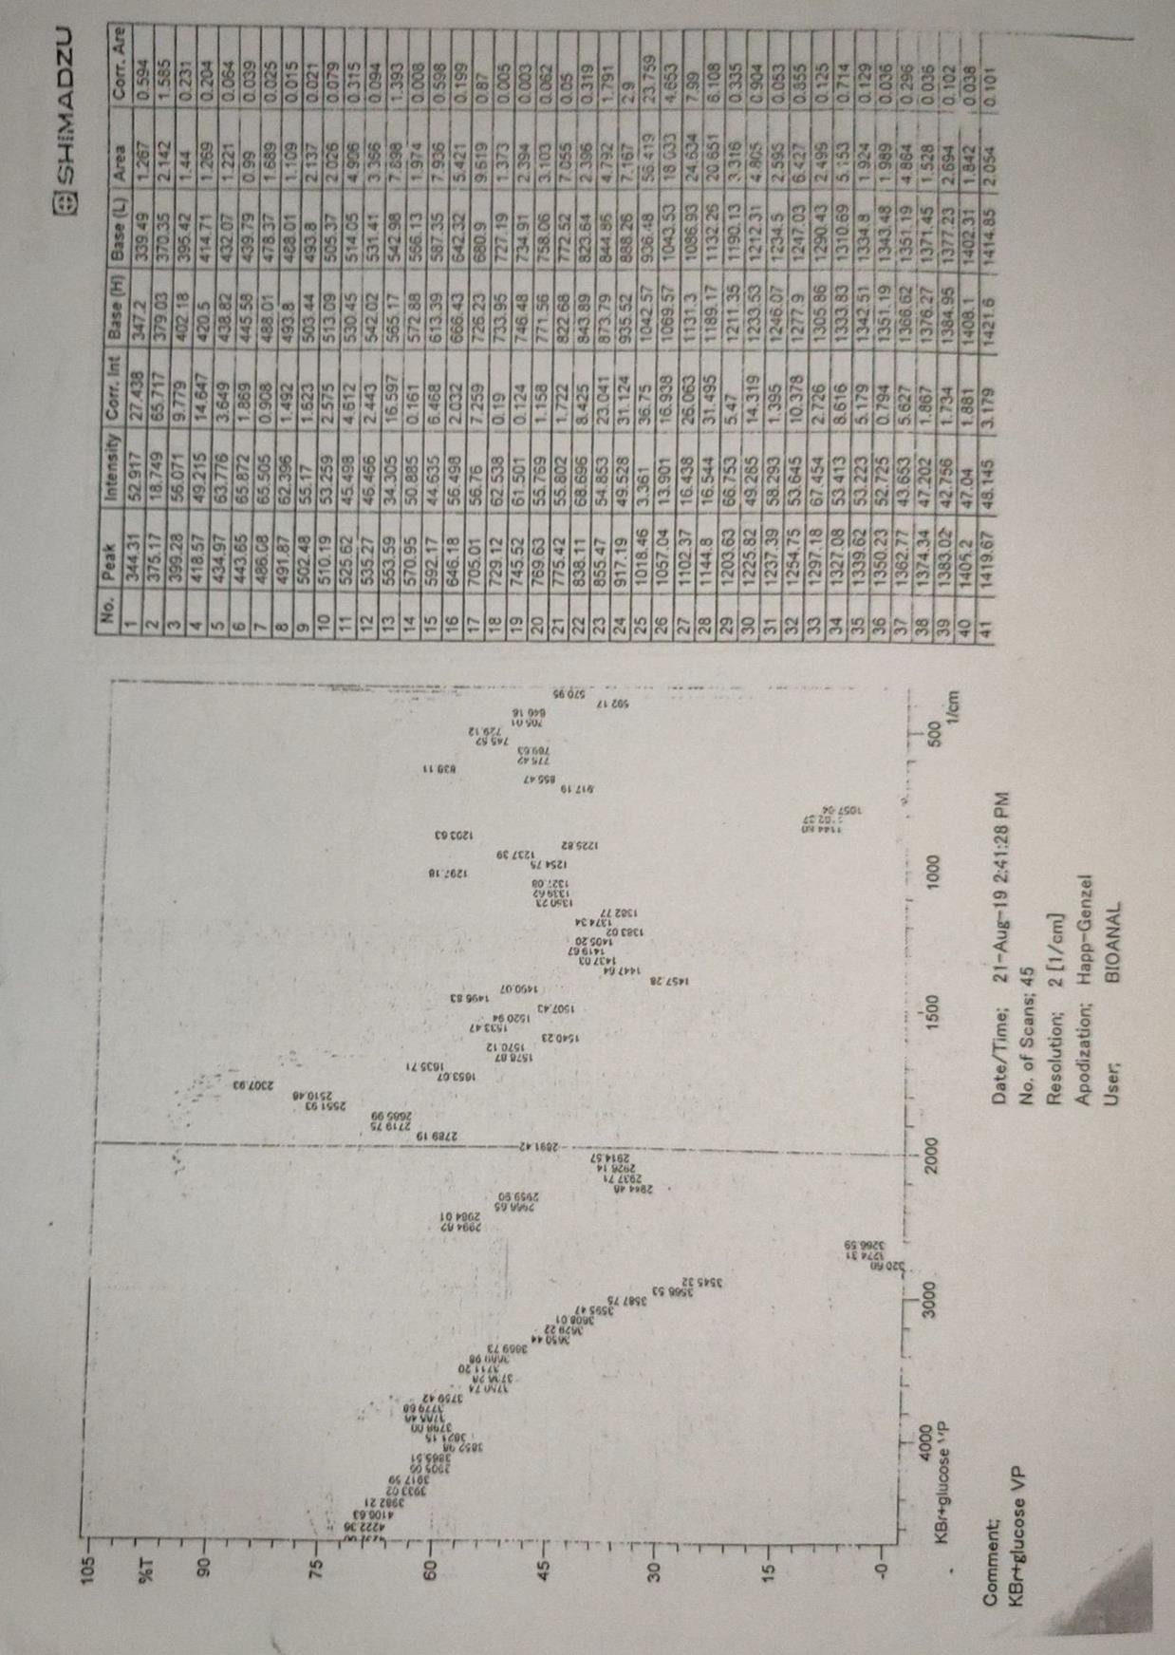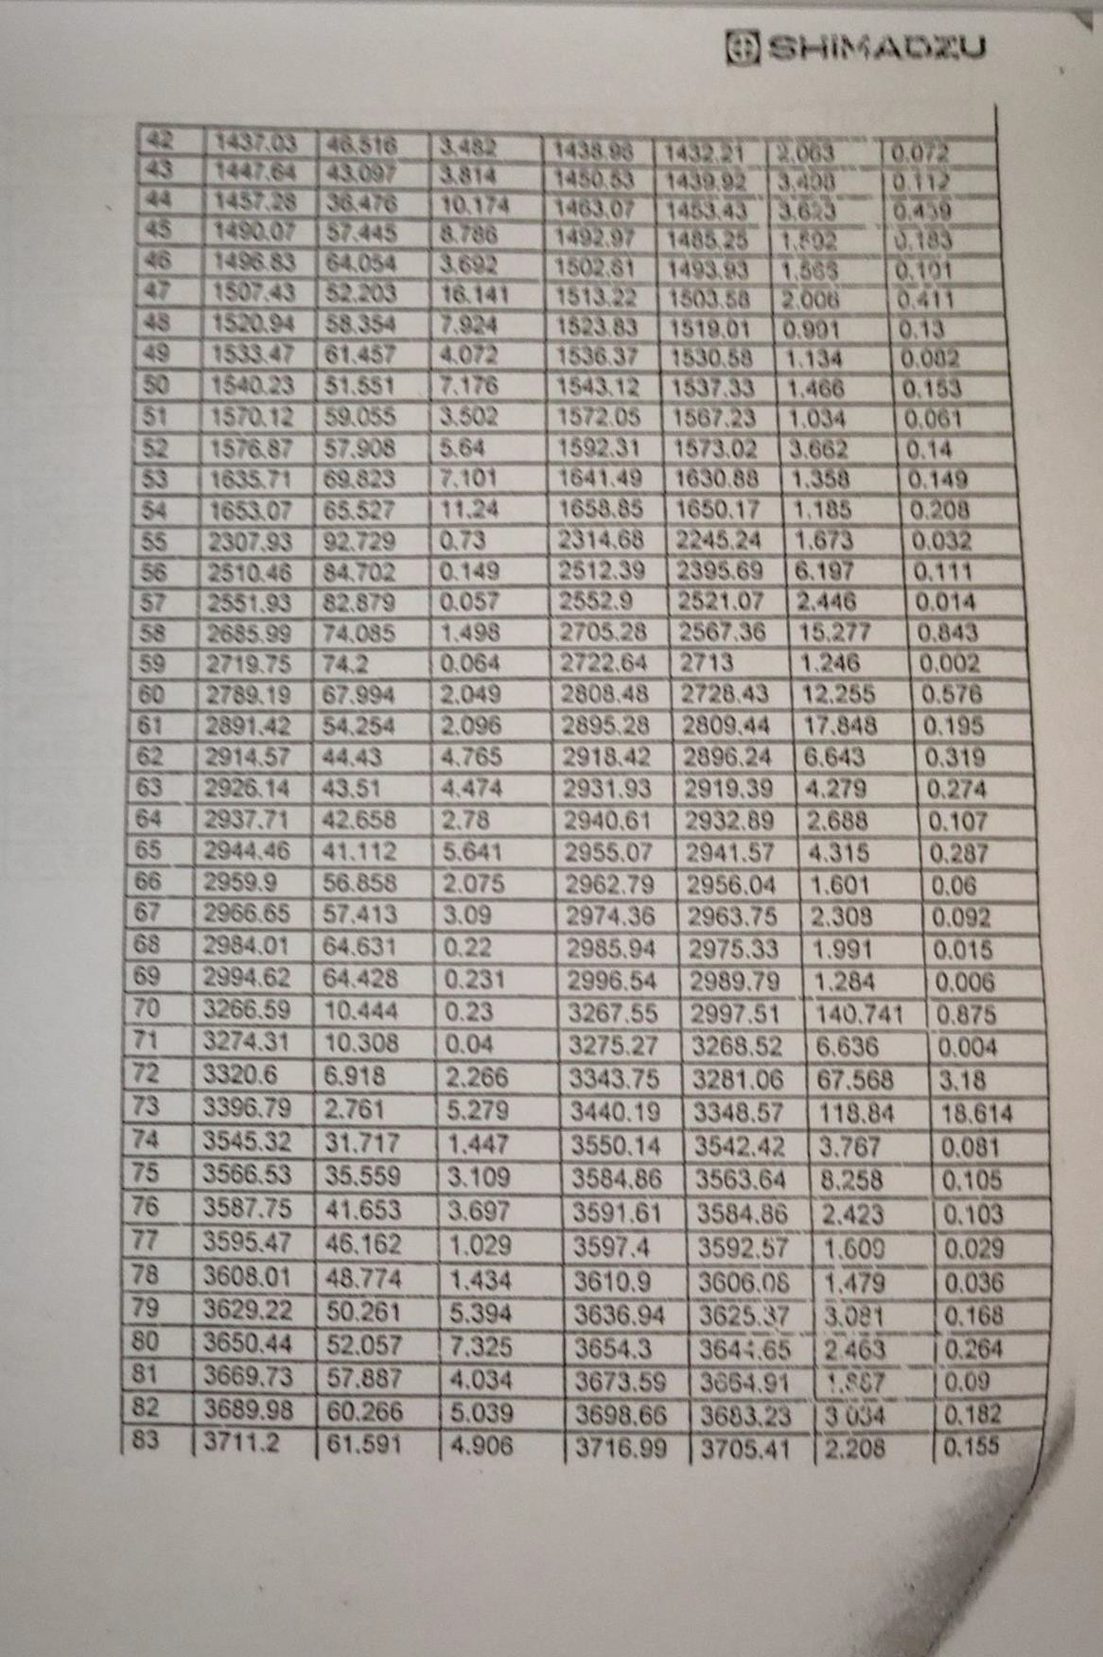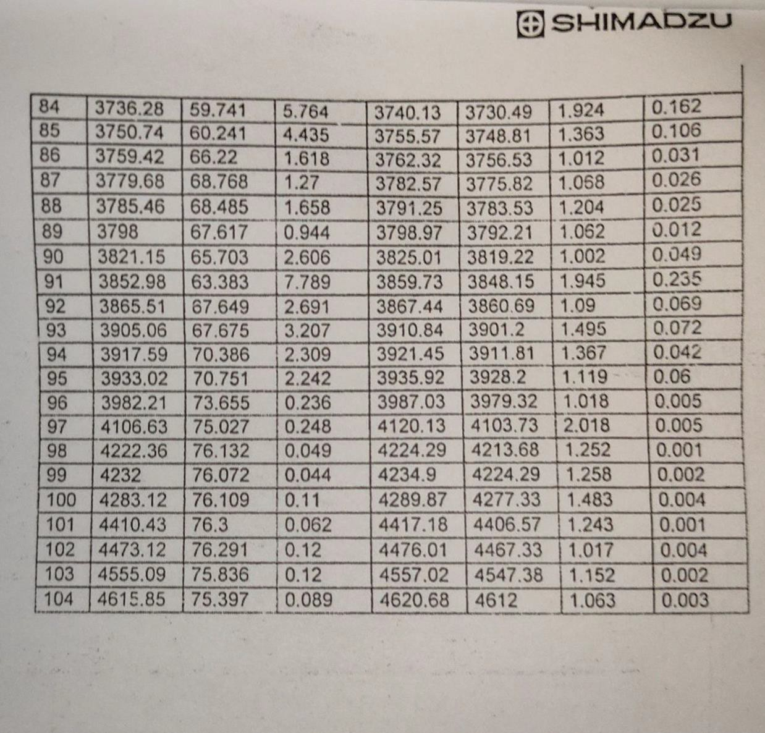

* + DICLOFENAC SODIUM (DFS) SPECTRUM

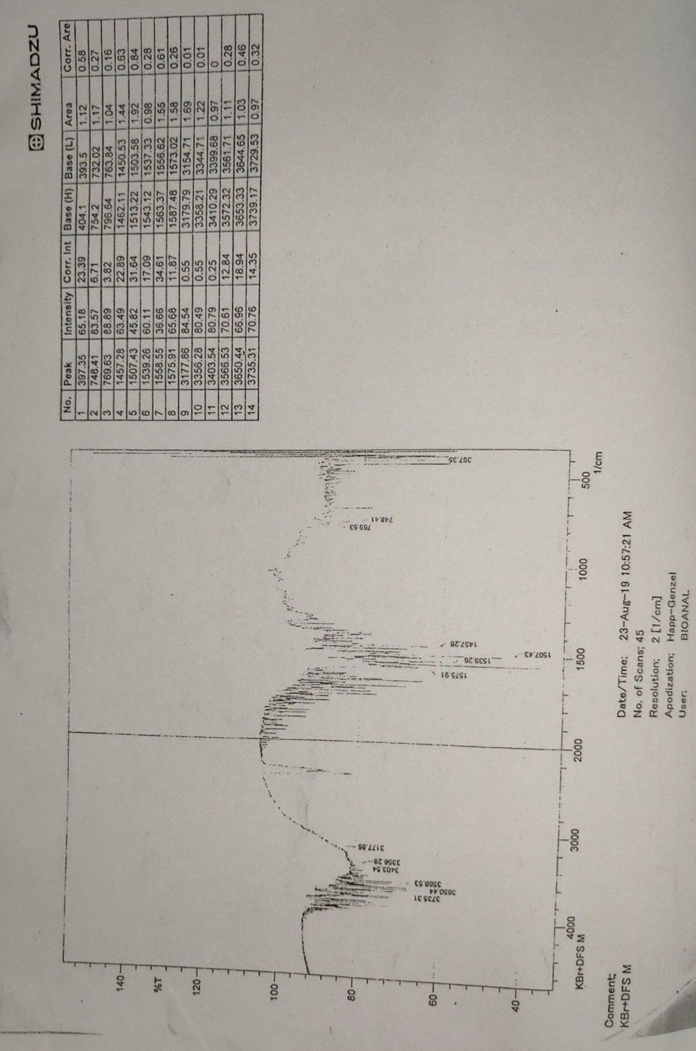

# OBSERVATION TABLE:

* + **GLUCOSE**

|  |  |  |
| --- | --- | --- |
| **Functional Group** | **IR Range (cm-1)** | **Peak (cm-1)** |
| -OH, -NH, >NH2, | 3600 - 3200 cm-1 | 3595.47, 8587.75, 3566.53, |
| C≡C-H (Medium bond at | 8545.32, 3396.79, 3320.6, |
| 3300 cm-1) | 3274.31, 3266.79 |
|  |  | 2994.62, 2984.01, 2966.65, |
| C-H Stretching |  | 2969.9, 2944.46 , 2937.71, |
| of methyl & methylene | 3000 – 2500 cm-1 | 2926.14, 2914.57, 2891.42, |
| -COOH broad bond |  | 2789.19 , 2719.75, 2655.99, |
|  |  | 2551.93, 2510.46 |
| C =0 Stretching  - ( 1750 - 1735 cm-1 )  C =0 Stretching of ester) | 1900-1650 cm-1 | 1653.07 |
|  |  | 1576 .87, 1570.12, |
|  |  | 1540.23, 1533.47, 1520.94, |
|  |  | 1502.43, 1496.83, 1490. 07, |
| C-O stretch at 1300 to 1050 cm-1  1150 - 1070 cm-1 | 1600-1000 cm-1 | 1457.28 , 1447.64 , 1438.03,  1419. 67, 1405. 2 , 1383.02,  1374.84, 1362.77, 1350.23, |
| C-0 stretching in >C-O |  | 1339.62, 1327.08, 1297.18, |
|  |  | 1254 .75, 1237.89, |
|  |  | 1225.82, 1203.83, 1144.86, |
|  |  | 1102.37, 1057.04, 1019.46 |
| 770-730 cm-1 (mono sub) | Below 1000 cm-1 | 769.63, 745.52, 729.12, |
| 850-710 cm-1 (m-disub) | 745.52, 769.63, 775.42, |
| aromatic ring | 838.11 |

* + **DICLOFENAC SODIUM**

|  |  |  |
| --- | --- | --- |
| **Functional Group** | **IR Range (cm-1)** | **Peak (cm-1)** |
| -OH, -NH, >NH2,  C≡C-H (Medium bond at 3300 cm-1) | 3600 - 3200 cm-1 | 3356.23, 3403.54, 3566.53 |
| =C-H Stretching + Ar-H Stretching | 3200-3000 cm-1 | 3177.65 |
| C-O stretch at 1300 -1050  cm-1, 1150-1070 cm-1  C-O stretching in =C-O | 1600-1000 cm-1 | 1575.91, 1553.55, 1539.25,  1507.43, 1457.28 |
| 770-730 cm-1 (mono sub ) 850-710 cm-1 (m-disub) aromatic ring | Below 1000 cm-1 | 769.53, 748.41, 397.35 |

# RESULTS:

1. Intact pellets of KBr-Glucose and KBr-DFS were prepared using pressure pump.
2. The interferograms were obtained specifically for the samples after the FTIR analysis.
3. The interferograms were correlated using co-relation charts and the reference interferograms.
4. After corelating with the IR reference charts, it can be observed that with respect to Glucose spectrum, the presence of -OH or amines, C-H, C=O, C-O, and aromatic ring functional groups were detected.
5. On the other hand, functional groups such as -OH or amines, C-H stretching, C-O stretch were detected in the DFS spectrum.

# CONCLUSION:

The infrared spectrum of Diclofenac Sodium (DFS) and Glucose were obtained successfully using Fourier Transform Infrared Spectroscopy (FTIR). FTIR is one of the sensitive methods which depends on the principle of Beer-Lambert law. Using this instrument, one can elucidate the functional groups present in the compound using reference charts. However, FTIR along with conjugation of other techniques would be required to confirm the compound of interest.